Mathematics – Grade 4

Quarter 1

Remote Learning

Practice and Enrichment Packet

Answer Key



**Quarter 1 Fourth Grade Standards-Aligned Tasks**

Hello SCS Family,

This resource packet was designed to provide students with activities which can be completed at home independently or with the guidance and supervision of family members or other adults. The activities are aligned to the TN Academic Standards for Mathematics and will provide additional practice opportunities for students to develop and demonstrate their knowledge and understanding.

A suggested pacing guide is included; however, students can complete the activities in any order over the course of several days. Below is a table of contents which lists each activity.

**Pennies for the Garden and Tall Towers**  **2**

**Mighty Mountains and Park Patrons**  **5**

**Multi-step Word Problems**  **9**

**Multi-step Word Problems**  **14**

**Convert Table Measurements**  **16**

**Playing Basketball and Jack & the Beanstalk**  **21**

**Multiplication**  **24**

**Earning Money and Dividing by One-Digit Numbers**  **29**

**Dividing by One-Digit Numbers** **34**

|  |  |
| --- | --- |
| **Week 1** | |
| **Fourth Grade Math Standards-Aligned Learning: Pennies for the Garden and Tall Towers** | |
| **Grade Level Standard(s)** | Standards for Task 1:  4.NBT.A.1 Recognize that in a multi-digit whole number (less than or equal to 1,000,000), a digit in one place represents 10 times as much as it represents in the place to its right. For example, recognize that 7 in 700 is 10 times bigger than the 7 in 70 because 700 ÷ 70 = 10 and 70 x 10 = 700.  4.NBT.A.2 Read and write multi-digit whole numbers (less than or equal to 1,000,000) using standard form, word form, and expanded form (e.g. the expanded form of 4256 is written as 4 x 1000 + 2 x 100 + 5 x 10 + 6 x 1). Compare two multidigit numbers based on meanings of the digits in each place and use the symbols >, =, and < to show the relationship. |
| **Caregiver Support Option** | 4th Grade students will solve real-world problems in which they have to consider the relationships between the digits in multi-digit numbers. They will use written and physical representations as well as mathematical reasoning to link the concept of place value to  comparisons and rounding. |
| **Materials Needed** | Recording sheet, pencil |
| **Question to Explore** | How does the position of a digit in a number affect its value? For any number, the place of a digit tells how many ones, tens, hundreds, and so forth are represented by that digit.  How can you represent the same number in different ways?  How did you decide how many pennies the 4th Grade donated for the garden project?  Why is multiplication an appropriate operation to use to solve this problem? |
| **Student Directions** | Use manipulatives or drawings to model multi-digit whole numbers.  Apply concepts of place value and multiplication to show that a  digit in one place represents ten times what it represents in the  place to its right.  Write multi-digit numbers in expanded form. |

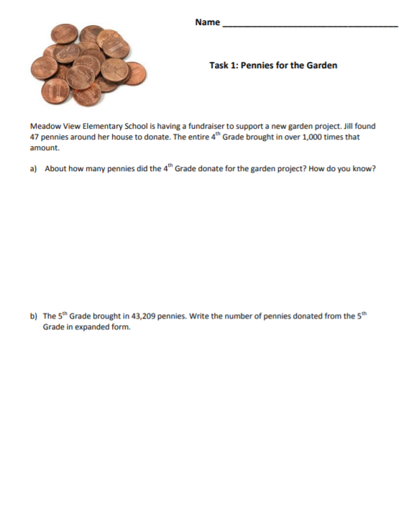

b) 43,209=(4 x 10,000) + (3 x 1,000) + (2 x 100) + (9 x 1) Students may include (0 x 10), which does not change the value and is acceptable.

The 4th Grade donated about 47,000 pennies to support the garden project. Students may multiply 47 x 1,000 to get the answer. Use the advancing questions to guide them to use place value understanding to explain their reasoning. Some students may know that by moving the decimal to the right, the original value is multiplied by 10. Those students might explain the answer by saying that moving the decimal place three spaces to the right multiplies the value of the original number by 1,000 to make 47,000. Other students may show their reasoning by using a place value chart like the one below. This shows the change in value with the arrows.

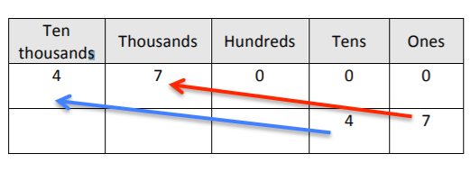

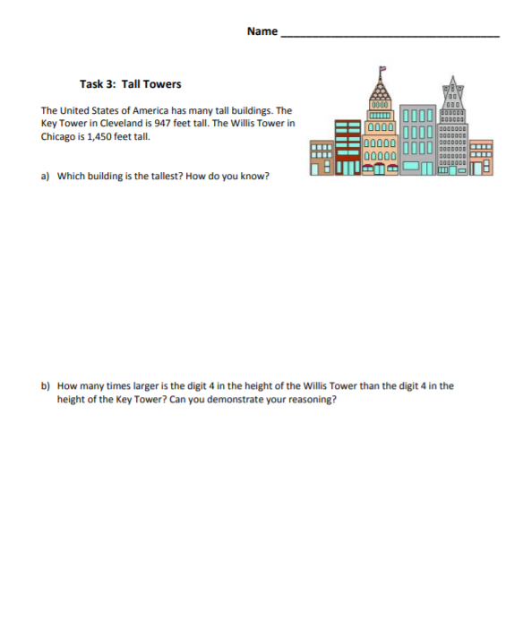

b) Students should explain that the digit 4 in the height of thse Willis Tower is 10 times larger than the digit 4 in the height of the Key Tower. Students should recognize that a digit in one place represents ten times what it represents in the place to its right. The 4 in the Willis Tower is in the hundreds place. By moving one place value location to the right, the 4 in the Key Tower is in the tens place.

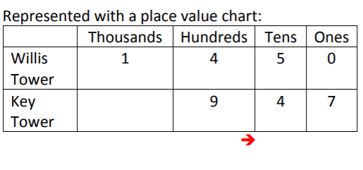

1. The Willis Tower in Chicago is the tallest. Students should show some reasoning involving place value to justify their answer. This might include a place value chart or base ten blocks.

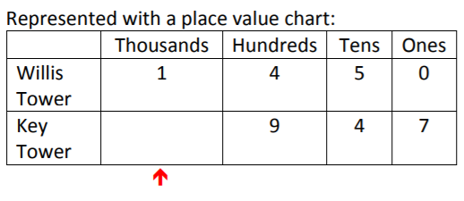

Both tower heights should be written in the place value chart so that corresponding place value locations are lined up vertically. Beginning with the largest place value location, Willis Tower has a 1 in the thousands place, while Key Tower does not have a digit in the thousands place.

|  |  |
| --- | --- |
| **Week 2** | |
| **Fourth Grade Math Standards-Aligned Learning: Mighty Mountains, Park Patron** | |
| **Grade Level Standard(s)** | 4.NBT.A.1 Recognize that in a multi-digit whole number (less than or equal to 1,000,000), a digit in one place represents 10 times as much as it represents in the place to its right. For example, recognize that 7 in 700 is 10 times bigger than the 7 in 70 because 700 ÷ 70 = 10 and 70 x 10 = 700.  4.NBT.A.2 Read and write multi-digit whole numbers (less than or equal to 1,000,000) using standard form, word form, and expanded form (e.g. the expanded form of 4256 is written as 4 x 1000 + 2 x 100 + 5 x 10 + 6 x 1). Compare two multidigit numbers based on meanings of the digits in each place and use the symbols >, =, and < to show the relationship.  4.NBT.A.3 Round multi-digit whole numbers to any place (up to and including the hundred-thousand place) using understanding of place value. |
| **Caregiver Support Option** | If this task is too difficult for some students, consider using smaller  numbers. Use the language “close to” and “closest to” to help  them understand rounding as a useful and natural activity. |
| **Materials Needed** | Recording Sheet, pencil |
| **Question to Explore** | Could writing the numbers in expanded form help in comparing them? Why or why not?  How does moving one place to the left change the value of the same digit in a multi-digit number? The value of the digit increases ten times.  How does moving one place to the right change the value of the same digit in a multi-digit number? The value of the digit decreases. |
| **Student Directions** | Read each question and solve. |

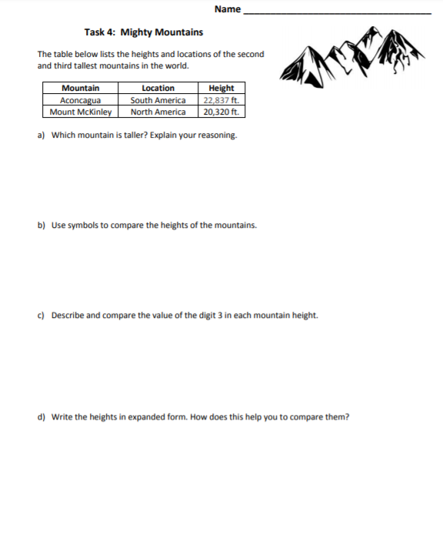

b) After completing part a), students should be aware than Aconcagua is taller than Mount McKinley. Using their heights for the numbers, either inequality below is an acceptable answer.

20,320 < 22,837 or 22,837 > 20,320

Both mountain heights should be written in the place value chart so that corresponding place value locations are lined up vertically.

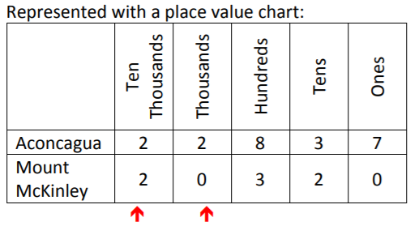

c) The 3 in Aconcagua’s height of 22,837 is in the tens place, so it represents 30. The 3 in Mount McKinley’s height of 20,320 is in the hundreds place, so it represents 300. The digit 3 has a larger value in Mount McKinley’s height than Aconcagua’s height, since 300 > 30 or 30 < 300.

a) Beginning with the largest place value location, ten thousands, both mountains have a 2 in this location. Moving to the next larger place value location, thousands, Aconcagua has the larger of the digits, 2. This indicates that Aconcagua is taller than Mount McKinley.

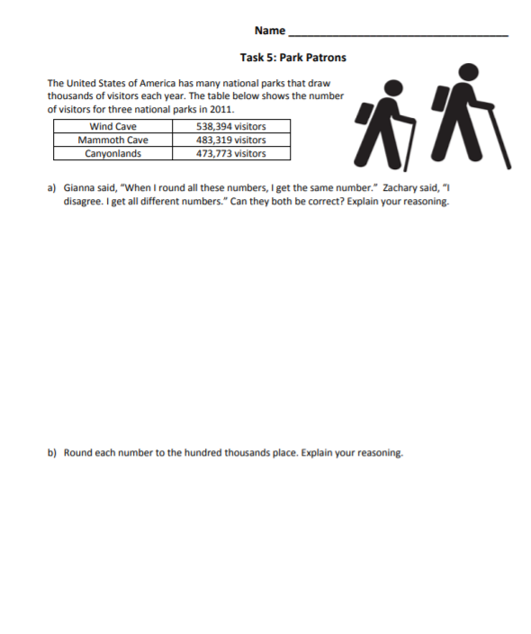

b) Students should round each number to 500,000, as shown in the table below.

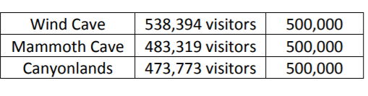

To help students understand rounding, they can think about zooming out on a number line between 400,000 and 500,000 for Mammoth Cave and Canyonlands or between 500,000 and 600,000 for Wind Cave.

a) Gianna is correct that all of these numbers round to 500,000 when they are rounded to the highest place value. Zachary is correct that all of these numbers round to different numbers when they are rounded to places other than the highest place value. Gianna’s reasoning is demonstrated in the explanation for part a). Answers may vary for Zachary, but the same reasoning can be used to explain Zachary’s answer. For example, he could round to ten thousands by changing the values on the number line to 530,000 and 540,000 for Wind Cave; 480,000 and 490,000 for Mammoth Cave; and 470,000 and 480,000 for Canyonlands.

Wind Cave rounds to 540,000

Mammoth Cave rounds to 480,000

Canyonlands rounds to 470,000

|  |  |
| --- | --- |
| **Week 3** | |
| **Fourth Grade Math Standards-Aligned Learning: Multi step Word Problems** | |
| **Grade Level Standard(s)** | 4.OA.A.3 Solve multi-step contextual problems posed with whole numbers and having whole-number answers using the four operations, including problems in which remainders must be interpreted. Represent these problems using equations with a letter standing for the unknown quantity. Assess the reasonableness of answers using mental computation and estimation strategies including rounding. |
| **Caregiver Support Option** | Students work by writing and solving equations for problems that  have more than two steps. Student write equations for multi-step  problems using letters to represent the unknown quantities. As with  all problem-solving, there may be more than one appropriate  approach. Give students time to think through their answers. |
| **Materials Needed** | Recording sheet, pencil |
| **Question to Explore** | Are you limited to using the same letter when writing equations? No, you can choose any letter you want to help you remember what quantity it stands for. |
| **Student Directions** | **Modeling Multistep problems**  Draw a model for the problem.  Use the model to write and solve the equation for the problem.  **Modeling Multi-step Problems**  Draw a line from the problem to an equation that represents the problems. Check all equations. |

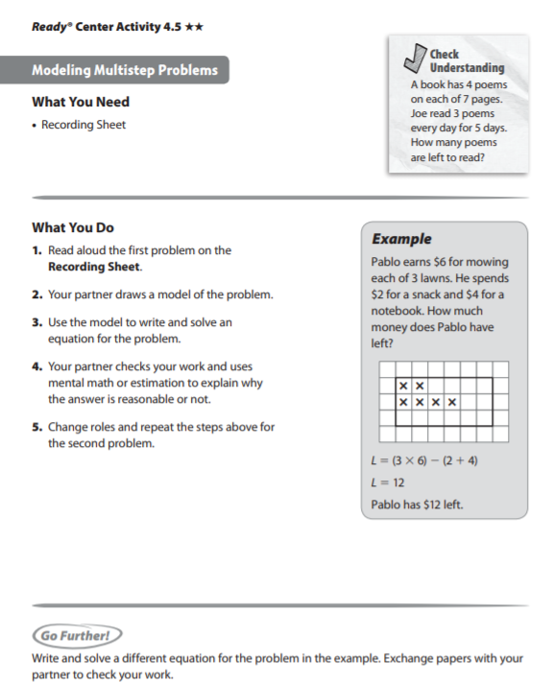

Check Understanding Answer key

13 poems

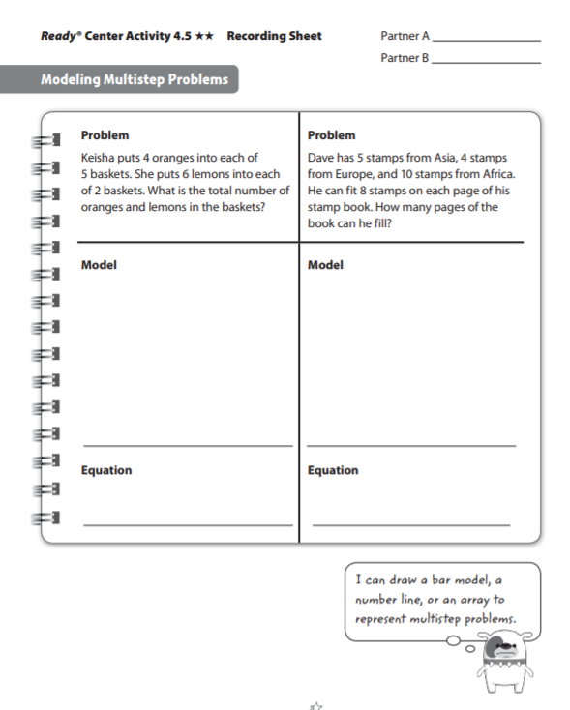

P= (5 +4+ 10) ÷ 8

P= 2 R3

2 pages

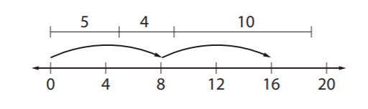

T= (5 x 4) + (2 x 6) T=32

32 oranges and lemons

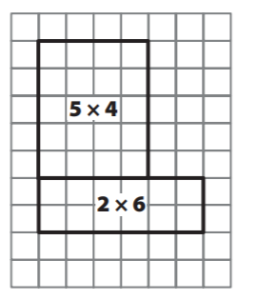

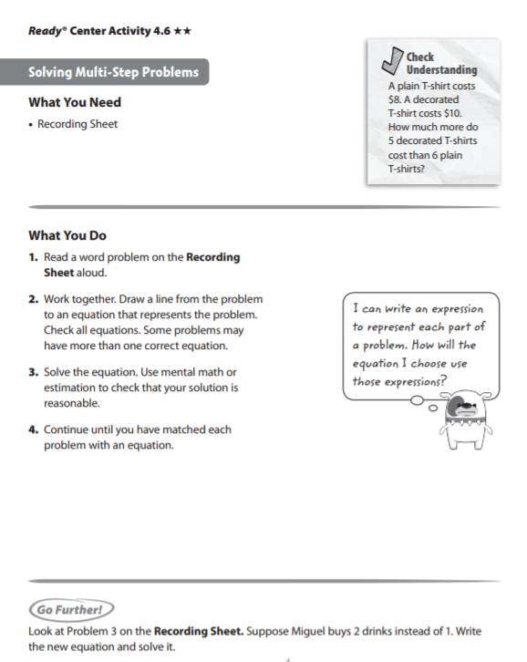

Check Understanding Answer Key

$2

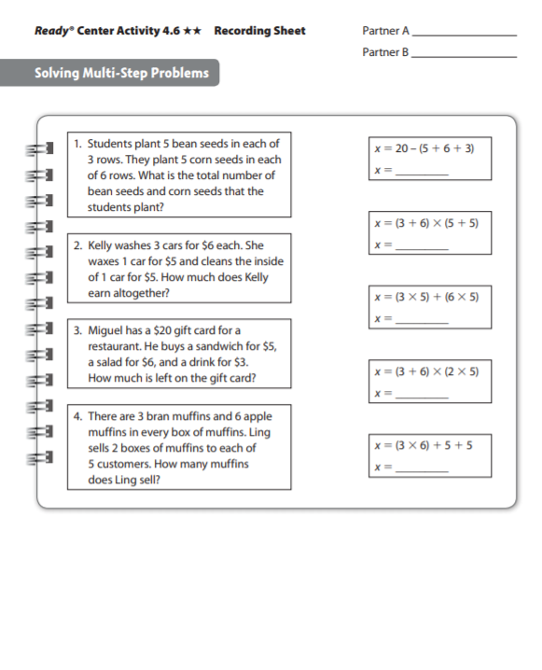

x=90

x = 28

x=45

x=90

x=6

|  |  |
| --- | --- |
| **Week 4** | |
| **Fourth Grade Math Standards-Aligned Learning: Multi step Word Problems** | |
| **Grade Level Standard(s)** | 4.OA.A.3 Solve multi-step contextual problems posed with whole numbers and having whole-number answers using the four operations, including problems in which remainders must be interpreted. Represent these problems using equations with a letter standing for the unknown quantity. Assess the reasonableness of answers using mental computation and estimation strategies including rounding.  4.NBT.B.4 Fluently add and subtract within 1,000,000 using appropriate strategies and algorithms. |
| **Caregiver Support Option** | Students work by writing and solving equations for problems that  have more than two steps. Student write equations for multi-step  problems using letters to represent the unknown quantities. As with  all problem-solving, there may be more than one appropriate  approach.  Give students time to think through their answers. |
| **Materials Needed** | Recording sheet, pencil |
| **Question to Explore** | Are you limited to using the same letter when writing equations? No, you can choose any letter you want to help you remember what quantity it stands for. |
| **Student Directions** | Read the word problem carefully. Answer each question. |

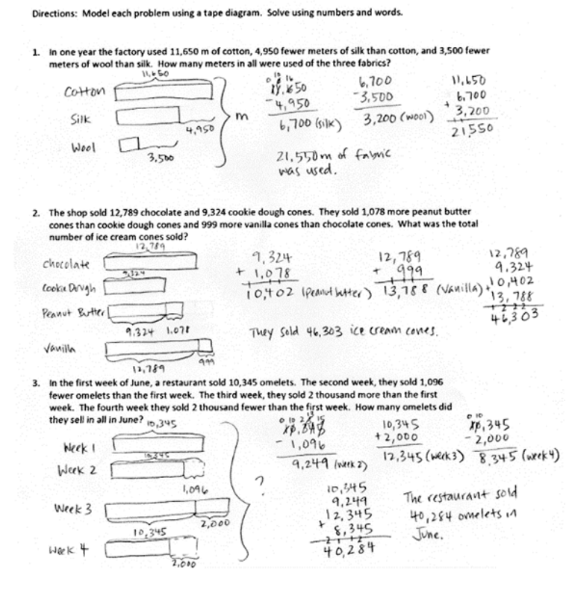

|  |  |
| --- | --- |
| **Week 5** | |
| **Fourth Grade Math Standards-Aligned Learning: Convert Table Measurements** | |
| **Grade Level Standard(s)** | 4.MD.A.1 Measure and estimate to determine relative sizes of measurement units within a single system of measurement involving length, liquid volume, and mass/weight of objects using customary and metric units.  4.MD.A.2 Solve one- or two-step real-world problems involving whole number measurements with all four operations within a single system of measurement including problems involving simple fractions. |
| **Caregiver Support Option** | Students use benchmark measures to estimate the number of  smaller unit; then they go on to express the relationship between  two measurement unit using multiplication. For example, an  object’s length in meters multiplied by 100 gives the length in  centimeters. Students use bar models, tables, and equations to  illustrate the multiplicative relationship and convert from the larger  unit to the smaller unit. |
| **Materials Needed** | Pencil, recording sheet, 6 game marker in one color, 6 game markers in a different color, game board |
| **Question to Explore** | How do you convert from a larger unit to a smaller unit? Multiply  the number of larger units by the number of smaller units in one  larger unit.  How can you calculate the number of ounces in one stick of  butter? There are 16 ounces in the entire box of butter, which is 4  sticks. Dividing 16 by 4 gives the number of ounces in one stick  of butter. Another method is to recognize that 4 pats of butter is  one ounce, and a stick of butter is 4 times as much, or 4 ounces. |
| **Student Directions** | Complete the table to show the measurement units are equivalent to the number of larger units.  Use the table to convert the measurement from the larger unit to the smaller unit. |

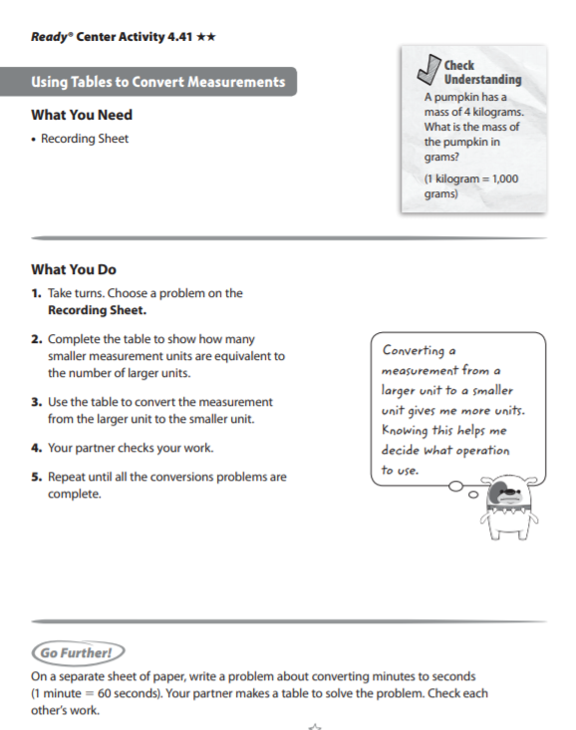

Check Understanding Answer Key

4,000 grams

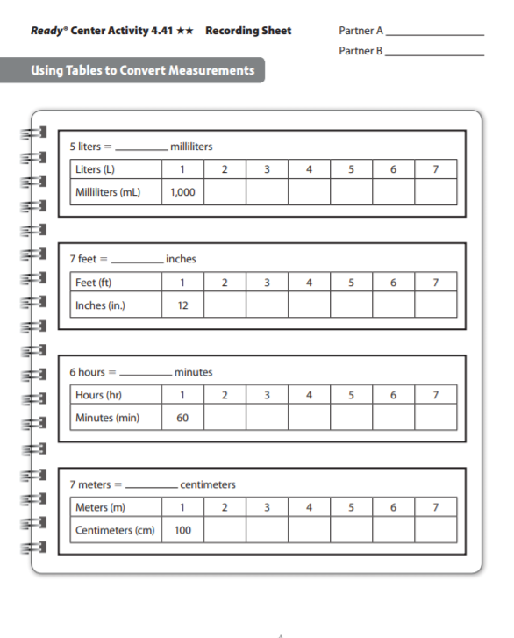

200 300 400 500 600 700

700

120 180 240 300 360 420

360

24 36 48 60 72 84

5,000

84

2000 3000 4000 5000 6000 7000

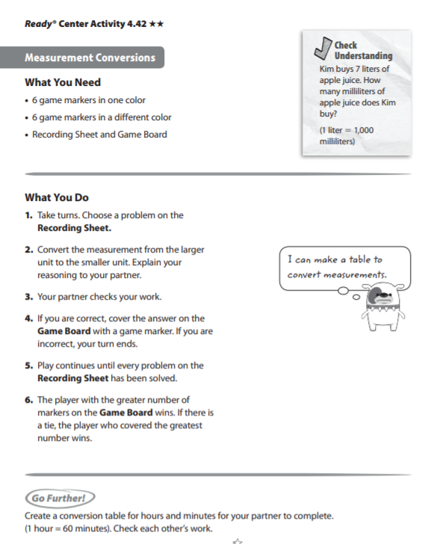

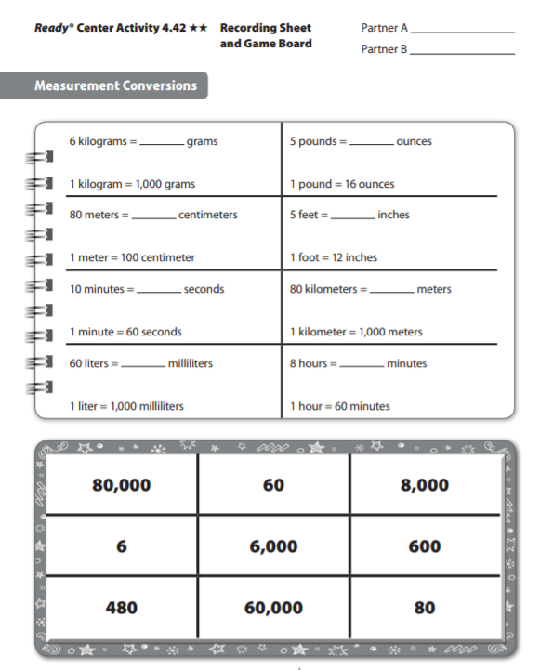

60,000

80,000

600

60

480

8,000

80

6,000

|  |  |
| --- | --- |
| **Week 6** | |
| **Fourth Grade Math Standards-Aligned Learning: Playing Basketball and Jack and the Beanstalk** | |
| **Grade Level Standard(s)** | 4.OA.A.1 Interpret a multiplication equation as a comparison (e.g., interpret 35 = 5 x 7 as a statement that 35 is 5 times as many as 7 and 7 times as many as 5). Represent verbal statements of multiplicative comparisons as multiplication equations.  4.OA.A.2 Multiply or divide to solve contextual problems involving multiplicative comparison, and distinguish multiplicative comparison from additive comparison. For example, school A has 300 students and school B has 600 students: to say that school B has two times as many students is an example of multiplicative comparison; to say that school B has 300 more students is an example of additive comparison. |
| **Caregiver Support Option** | Students are introduced to the concept of multiplicative comparison  when the product is unknown. Task: Playing Encourage students to  identify the patterns shown in the visual representation as they  describe their thinking to others. Encourage students to continually  reference the context when thinking through the problem and  explaining their thinking. |
| **Materials Needed** | Recording sheet, pencil |
| **Question to Explore** | Why can we write 4 x 2? (We can write this because he did 4 and  then 4 more.) What made you write 4 + 4 or 2 groups of 4? (Uncle  David made two times the number of shots that Gabe made.) How  can we write this as a multiplication equation? (2 x 4 or 4 x 2) |
| **Student Directions** | Read each problem below. Read each question and respond. Use the RDW process- Read the problem, Draw a model, Write an equation and a sentence. |

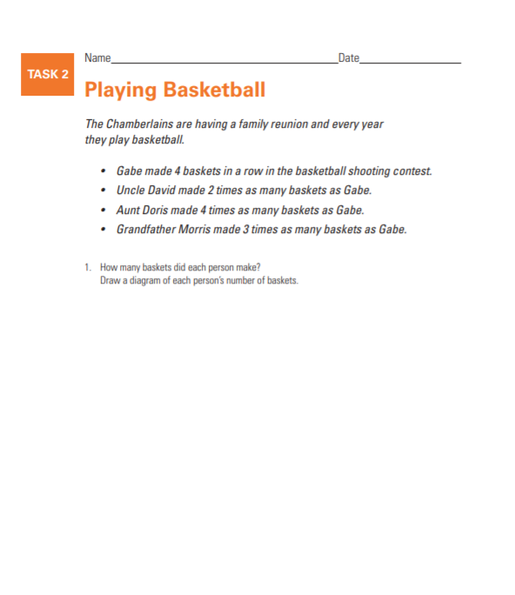

4 x 1 = 4

4 x 2 = 8

4 x 4 = 16

4 x 3 = 12

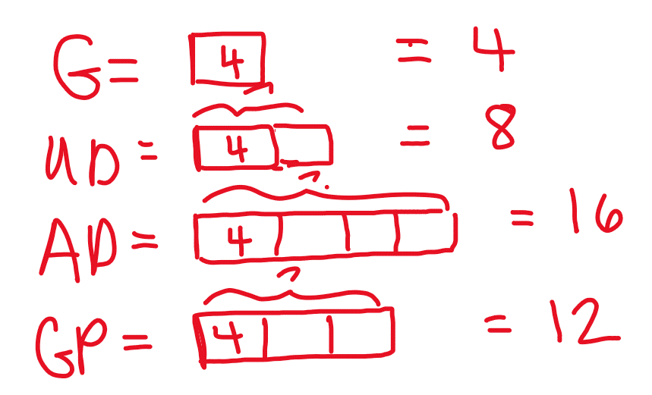

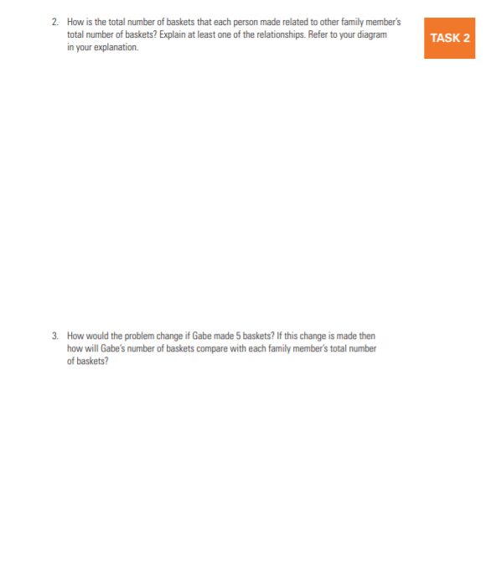

5 x 1 =5

5 x 2= 10

5 x 4 = 20

5 x 3 = 15

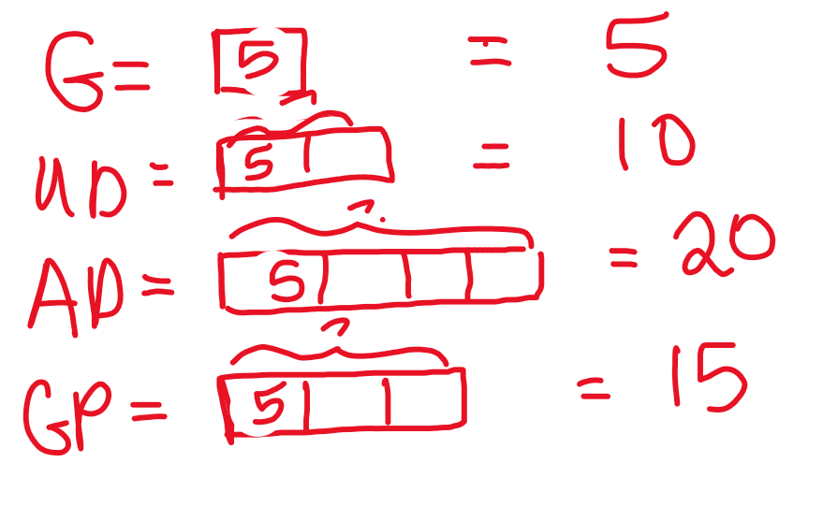

Gabe’s amount remains the constant and the family members are scaled up based up based on Gabe’s amount (scaling factor). 5 appears in each equation.

My tape diagrams show that Uncle David made two times the number of shots that Gabe made.

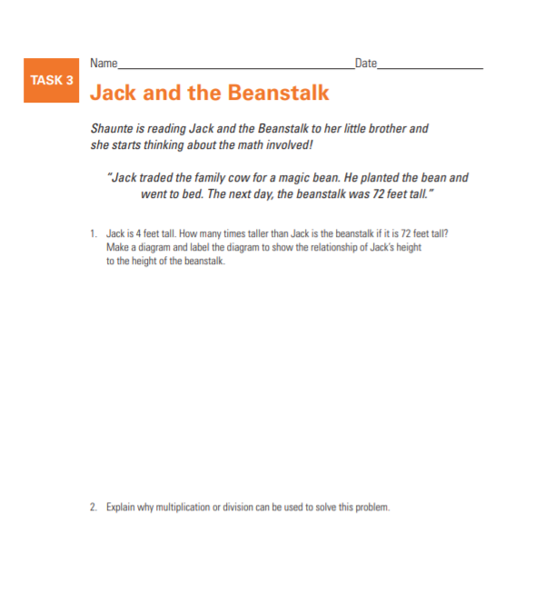

Multiplication and division both have a constant and scaling factor. A situation that can be represented by multiplication has an element that represents the scalar and an element that represents the quantity to which the scalar applies. A repeated relationship exists within an amount that is x times more than or x times less than a given amount and this relationship remains constant in a set that is scaled. In a scalar relationship the amount that remains constant can be determined by using division when one of the factors and the total amount are known.

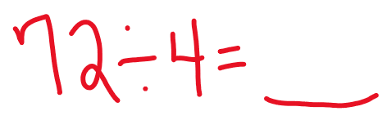

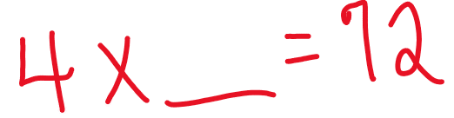

The beanstalk is 18 times as large as Jack.

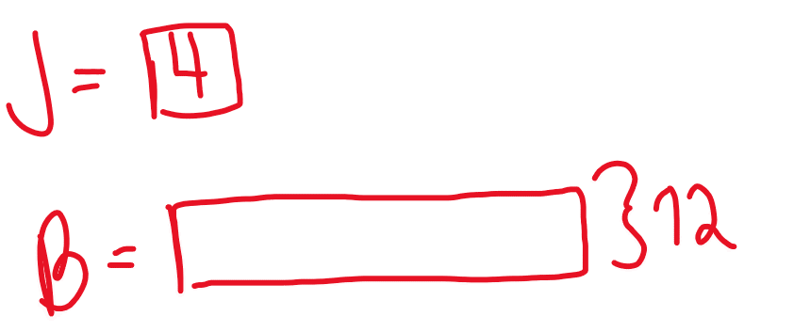

|  |  |
| --- | --- |
| **Week 7** | |
| **Fourth Grade Math Standards-Aligned Learning: Multiplication** | |
| **Grade Level Standard(s)** | 4.NBT.B.5 Multiply a whole number of up to four digits by a one-digit whole number and multiply two two-digit numbers, using strategies based on place value and the properties of operations. Illustrate and explain the calculation by using equations, rectangular arrays, and/or area models. |
| **Caregiver Support Option** | Student broadened their conceptual understanding of multiplication  to include the idea of multiplication as a comparison of two  numbers. Students use area models and partial products to multiply.  They apply their understanding of place value to multiply three- and  four-digit numbers by a one-digit number and to multiply a two- digit  number. |
| **Materials Needed** | Recording Sheet, game board, two different color game markers |
| **Question to Explore** | How can you relate partial products methods to the distributive  property? The partial products method is an example of the  distributive property. The distributive property states that you can  multiply a number and sum by multiplying the number by each  part of the sum and then adding these products. |
| **Student Directions** | Multiply. Tell what method you used. Have a partner check your work with a different method. |

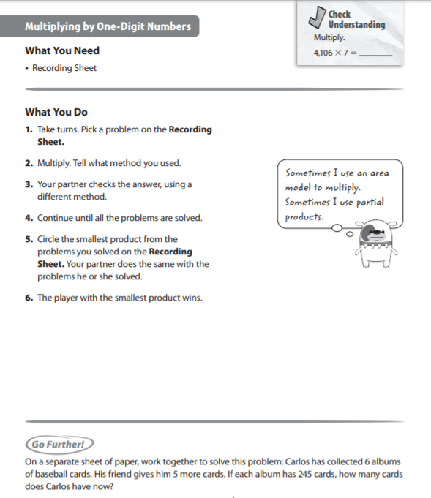

Check Understanding Answer key

28,742

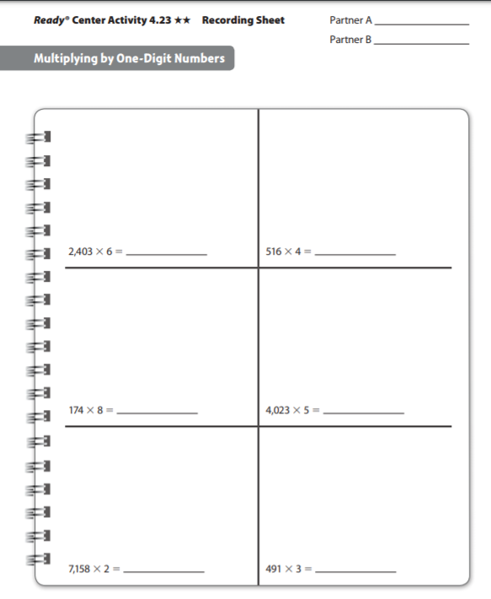

14,418

2,064

1,473

14,316

1,392

20,115

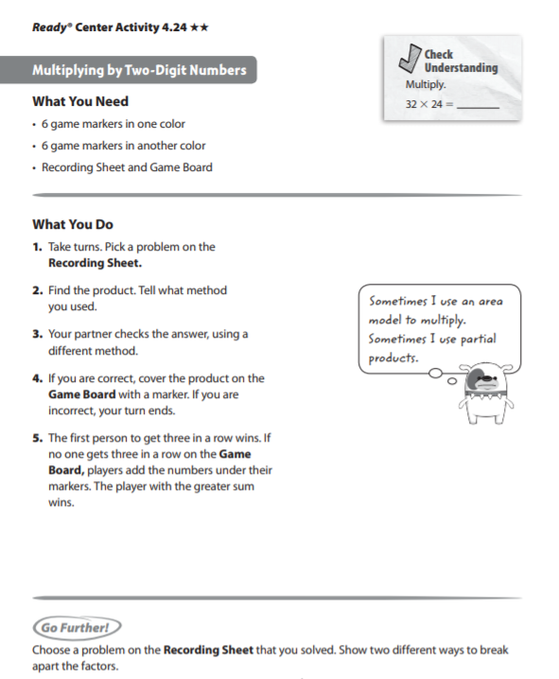

Check Understanding Answer Key

768

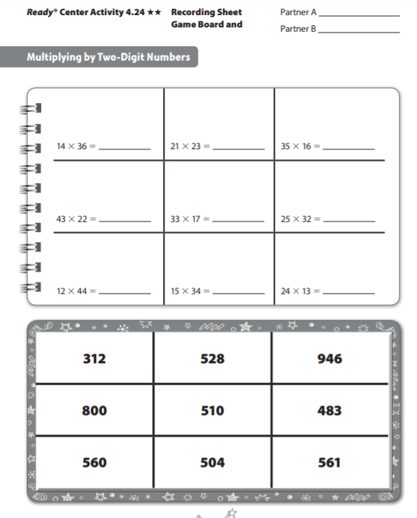

483

800

528

312

510

561

946

560

504

|  |  |
| --- | --- |
| **Week 8** | |
| **Fourth Grade Math Standards-Aligned Learning: Earning Money and Dividing by One-Digit Numbers** | |
| **Grade Level Standard(s)** | 4.OA.A.1 Interpret a multiplication equation as a comparison (e.g., interpret 35 = 5 x 7 as a statement that 35 is 5 times as many as 7 and 7 times as many as 5). Represent verbal statements of multiplicative comparisons as multiplication equations.  4.OA.A.2 Multiply or divide to solve contextual problems involving multiplicative comparison, and distinguish multiplicative comparison from additive comparison. For example, school A has 300 students and school B has 600 students: to say that school B has two times as many students is an example of multiplicative comparison; to say that school B has 300 more students is an example of additive comparison.  4.NBT.B.6 Find whole-number quotients and remainders with up to four-digit dividends and one-digit divisors, using strategies based on place value, the properties of operations, and/or the relationship between multiplication and division. Illustrate and explain the calculation by using equations, rectangular arrays, and/or area models. |
| **Caregiver Support Option** | Be sure to help students understand the parts of a division problem.  Use the following references so students can differentiate the  terminology:  Dividend ÷ divisor = quotient |
| **Materials Needed** | Recording sheet, 6 game markers in one color, 2 game markers in a different color, game board |
| **Question to Explore** | Why do you subtract partial products to divide? Students’  responses should mention that the goal is to find products that add  up to the dividend. After finding each product, subtract the  amount from the dividend to see if you can find another product.  You repeat this product until the difference is a number less that  the divisor. |
| **Student Directions** | Earning money all parts carefully. Answer each question. Use the  RDW process to solve the problems. Read the problem. Draw a  model. Write an equation and a sentence. |

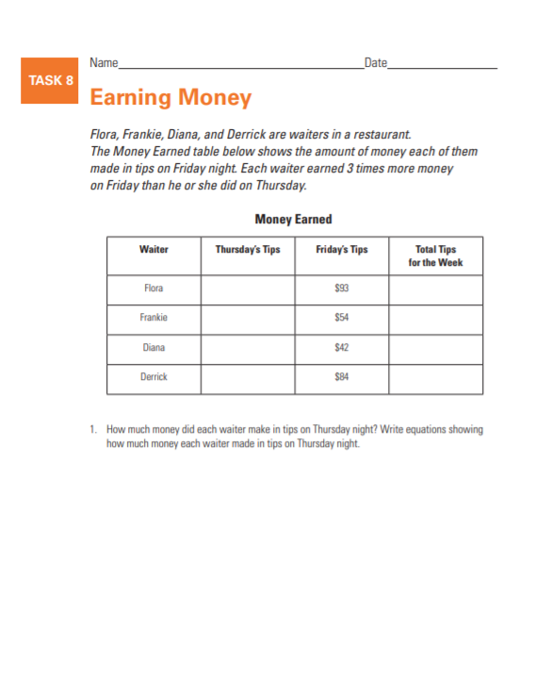

Flora 93 ÷ 3 = 31 Flora $31

Frankie 54 ÷ 3 = 18 Frankie $18

Diana 42 ÷ 3 = 14 Diana $14

Derrick 83 ÷ 3 = 28 Derrick $28

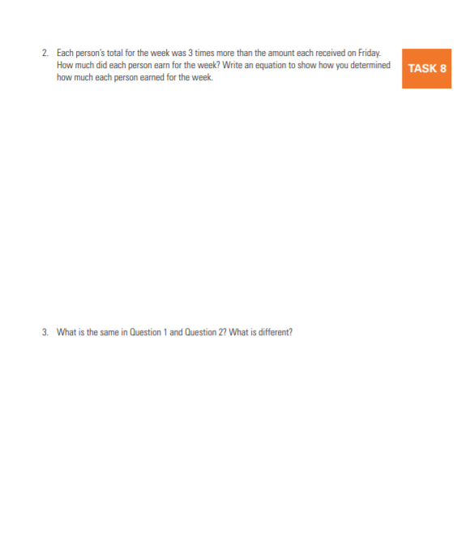

Flora 93 + 31 = 124 Flora $124

Frankie 54 + 18 = 72 Frankie $72

Diana 42 + 14 = 56 Diana $56

Derrick 83 + 28 = 112 Derrick $112

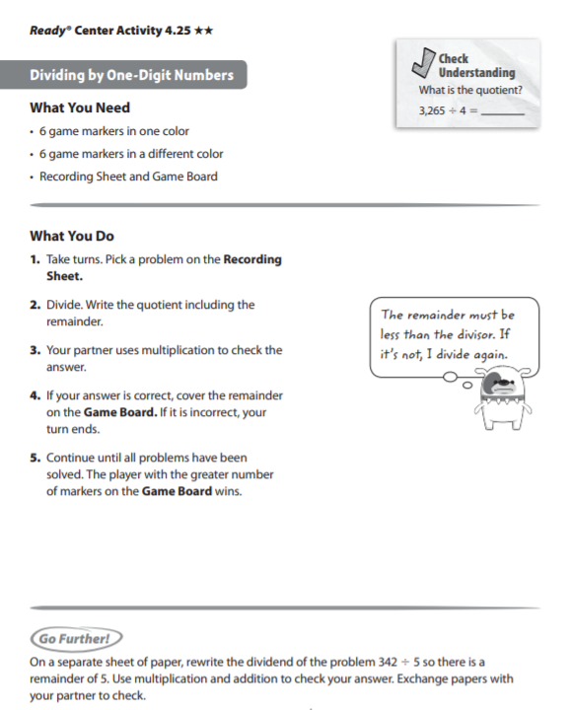

Check Understanding Answer Key

816 R1

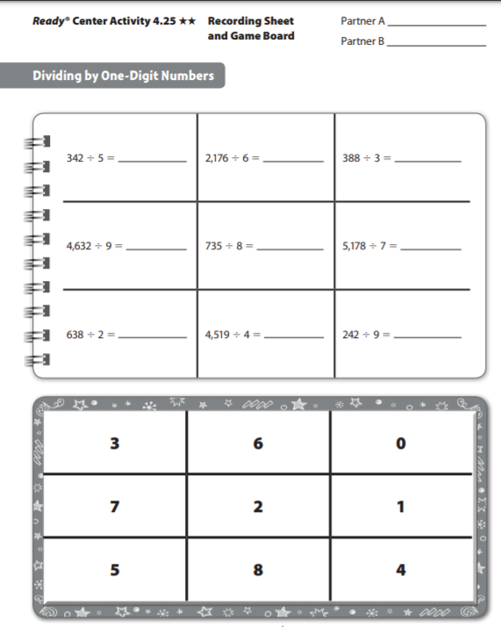

739R5

91 R7

26 R8

1,129 R3

319

514 R6

68 R2

362 R 4

129 R1

|  |  |
| --- | --- |
| **Week 9** | |
| **Fourth Grade Math Standards-Aligned Learning: Dividing by one-Digit Numbers** | |
| **Grade Level Standard(s)** | 4.NBT.B.6 Find whole-number quotients and remainders with up to four-digit dividends and one-digit divisors, using strategies based on place value, the properties of operations, and/or the relationship between multiplication and division. Illustrate and explain the calculation by using equations, rectangular arrays, and/or area models. |
| **Caregiver Support Option** | Students apply their knowledge of basic facts, along with place-  value understanding of properties of operations, to solve multi-digit  division problems. Students divide three- and four-digit number by  one-digit numbers. They are area models to divide, apply the idea of  subtracting partial products to divide, and learn how to find partial  quotients to divide. |
| **Materials Needed** | Recording Sheet, 6 game markers in one color, 2 game markers in a different color, game board |
| **Question to Explore** | Think of times when you need to use division in everyday life.  Cooking (splitting ingredients or cutting the recipe down in size),  sharing of distributing a number of objects to a number of people |
| **Student Directions** | Write the quotient including the remainder. Have a partner the  answers using multiplication. |

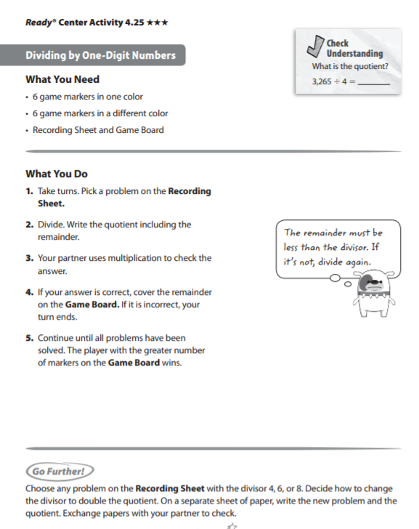

Check Understanding Answer Key

816 R1

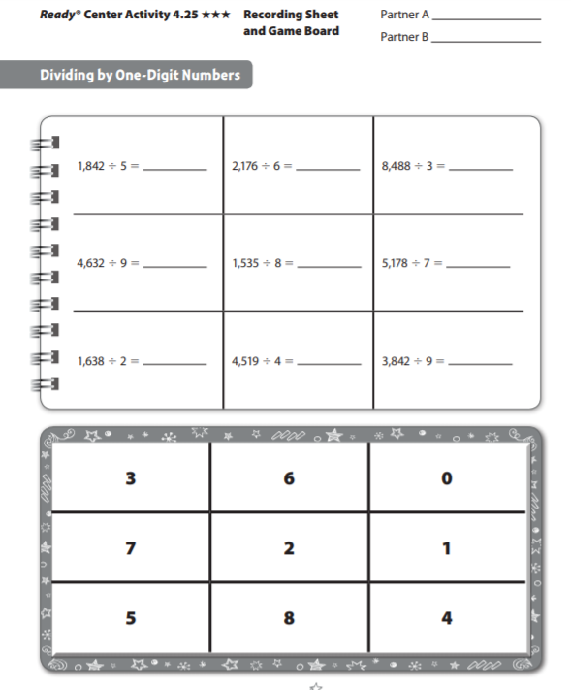

368 R2

362 R4

2,829 R1

739 R5

191 R7

514 R6

819

1,129 R3

426 R8